**Recommender Systems: Scaling up with Big Data**

**Apache Spark**

* Can handle RDD (Resilient Distributed Dataset), DataFrame, and DataSet.

**Amazon DSSTNE**

* Possible to set up deep neural networks with sparse datasets
* Runs on GPUs.

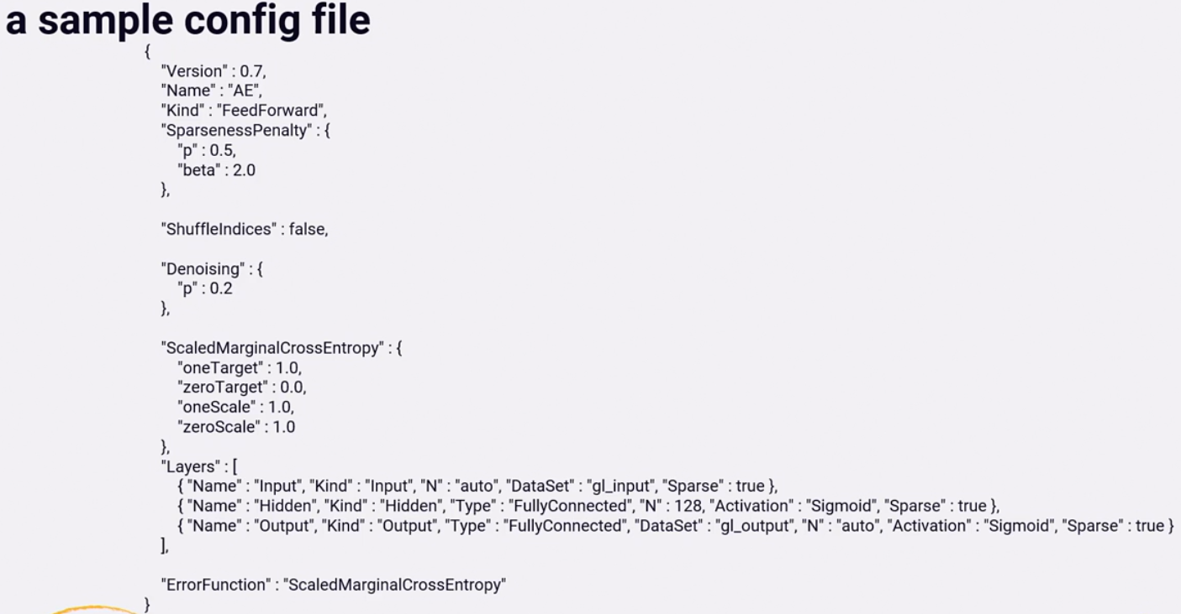

**Amazon Sagemaker**

* Need to convert to protobuf